Chris Haerle

Southern New Hampshire University

CS-405 2-3 Activity: Buffer Overflow Code

9-10-2022

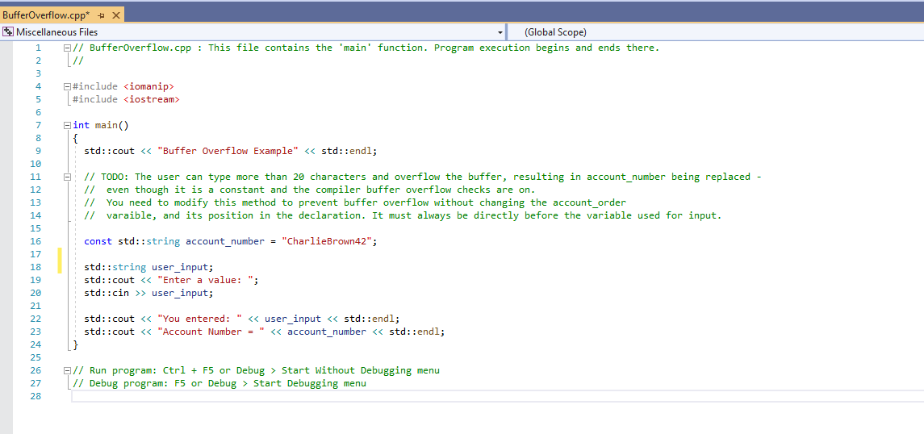

For this assignment, we were suppose to modify the code to prevent buffer overflow without changing the account_order. I removed the “char user_input[20];” and I added in “std::string user_input;”. I could have adjusted the char[20] to char[30] or char[40] but it needs to be a constant while the string doesn’t need to be constant. This is helpful too because we don’t have to define the size of the string like we do with the char.